Paper Title* (use style: paper title)
*Note: Sub-titles are not captured in Xplore and should not be used
line 4: City, Country
line 5: email address or ORCID

Abstract—This article is an examination and reconstruction of Richard Sutton’s 1988 paper “Learning to Predict by the Methods of Temporal Differences”. In it, Sutton introduces two prediction algorithms; conventional supervised learning and temporal difference. He goes on to propose TD methods as being superior with respect to dynamic environments and demonstrates such with a simple Markov experiment. The contextual paradigm of superiority between the two algorithms is bounded by two key attributes, computational efficiency and accuracy. Here, we aim to achieve statistical repeatability of these experiments and provide further analysis of results.

Introduction
This article centers around Temporal Difference methods and their efficacies for prediction problems. It is a replication of experiments performed in Sutton’s 1988 paper Learning to Predict by the Methods of Temporal Differences. In it he argues that TD methods are not only more accurate than conventional supervised learning methods, but they’re more computationally efficient while leading to faster convergence. Historically, conventional supervised learning methods have been used due to the ease of interpretable results and understanding. Sutton points out, howerever, that this is merely the case because TD methods “were never studied independently”. Ultimately, he formally proves convergence of TD methods and demonstrates, experimentally, their superiority with respect to prediction problems involving dynamic systems.
The conventional supervised learning paradigm is one in which a mapping function is learned through iterative updates of a weight vector. These updates are a function of the error between prediction and true observation. More formally, supervised learning aims to optimize an objective function by minimizing prediction error. Upon convergence, optimization should produce a model that can make predictions with high accuracy. There are many optimization functions used, and for different reasons. However that is outside the scope of this article. Instead, the main thing to note is that optimization is solely dependent on input to output mappings of i.i.d observations. No sense of sequence or “temporal difference” is accounted for during training. A common example of this is the prediction of housing prices when given inputs (features) of square footage, number of rooms, number of bathrooms, zip code, etc. Given these inputs to an optimized model, it should produce a close to accurate price.
A problematic consequence of this global approach is the lack of sequential information. In practice, supervised learning trains predictive models from sampled data. If the given data sampled, in this example, were over the course of 10 years for a specific area, this sampling would fail to account for rate of changes of inflation, equity, and/or market reactions. According to the law of large numbers, sampling multiple times from this large time span dataset would yield a more central price. This might be sufficient for general pricing. But for the sake of accuracy with resepect to current pricing trends, this method would fall short.
As an anecdotal example, we want to predict how much a house will sell for if it’s expected to to sit on the market for at least 2 months. The house is in a particular zip code where resale values have been increasing at a constant rate year over year. However, a recession has recently hit the housing market and prices are in decline. Supervised learning would fail to account for this more recent sequential drop in price prediction. It would still provide a central number based off of all historical data available. This paradigm is one in which Sutton argues that TD methods would be more accurate. Using TD methods, continual price drops month after month would update pricing expectations with respect to this downard trend immediately. Week 1 might predict the price to be $450k. But after another week of recession struggles, comparable homes in the neighbhorhood have been selling at 10% below asking. With TD, we can update our prediction to account for this drop and adjust the $450k price point immediately. Conversely, with supervised learning, a substantial amount of price drop data would have to be accumulated over time and the model retrained, in order to realize a significant effect of the recession.
For completeness, TD exploits the Markov property whereas supervised learning does not. TD methods can be in the form of bootstrapping (creating estimates from estimates), sampling (what supervised learning does), or a combination of the two. When trying to predict in a dynamic system Sutton’s experiments attempt to show, in the simplest case, that TD methods in fact perform better than convetnional learning because of this exploitation. With that, we recreate his analysis to asses repeatability and confirmation of his results.
- supervised Learning vs TD(λ)
Complete mathematical proof and rigor behind the concepts surrounding this article is beyond scope. We only introduce key concepts and equations here for continuity and the minimization of ambiguity. Supervised learning as described by Sutton, as well as how it is generally regarded, is learning with respect to input / target pairs (X_{i}, y_{i}) where Xi is input features and yi is the target value. A mapping function consisting of weights is learned during training such that a linear combination of these weights and X_{i} results in a prediction Pt. Sutton notates this linear combination as
Pt =w^{T}x_{t} = S_{i} w(i) x(i) 
The error between Pt and yi (yi – Pt) is the subject of optimization. More formally, supervised learning aims to reduce the error between prediction and ground truth for each observation in Xi. Being that the observations Xi and target values yi are constant throughout the learning process, error in predictions is attributed to values of the weights themselves. Again, with no rigor provided, the weight update procedure is

w ← w + Σ_{t=1} Δw_{t} (2)
Where w is each weight in the vector wi and Dwt is the gradient of the weight vector with respect to component t.

Dw_{t} = α(y_{i} - P_{t})Δ_{w}P_{t} (3)

We only make note here of the update procedure on the weights during training without formal proof or derivation. The importance of highlighting this update in-place is so that the connection between supervised learning and TD(lambda) can be realized. Alpha in equation 3 is the learning rate. This is a tune-able hyperparameter that dictates how much error we want to correct our weights for.

TD(lambda) has a similar update structure for its weights. The main thing to note however is that there is not a linear function mapping inputs to outputs. The value of a particular state is defined as the expected reward from being in that state and transitioning either in a finite or infinite horizon. Therefore, we need not find weights for an extrapolated mapping function. We simply initialize state values, and update those values with actual returns experienced from the dynamics of the environment continually until convergence.

Δw_{t} = α(P_{t+1} – P_{t})Σ_{k=1} λ^{t-k}Δ_{w}P_{k} (4)
With no formal proof, note that when lambda is equal to 1, equation 4 is equivalent to equation 3. Therefore, TD(1) produces the same weight updates as supervised learning. This is an important distinction to keep in mind when evaluating the experiment. Because TD(1) and supervised learning is equivalent, the results of TD(1) compared to all other values of lambda are reflective of the performance of supervised learning compared to all other values of lambda.

The experiment
Sutton’s experiment to highlight the efficacies of TD methods was a simple one in principle. He proposed a bounded random walk. Given seven different states [A, B, C, D, E, F, G], a walk always starts at state D. The only actions allowed during this walk is a one step transition either to the left or right. The action space is one of equal probability in that, there’s a 50% chance of going left or 50% chance of going right. The state you are in bares no influence on the action taken. A walk is deemed terminal whenever either state A or G has been reached. Transitions between states [B, C, D, E, F] yield zero reward. In fact no reward, either positive nor negative, is achieved unless state G has been reached. Reaching terminal state A nets 0 reward while state G nets a reward of 1. Figure 1 shows the exact depiction of the experiment as presented in Sutton’s paper.
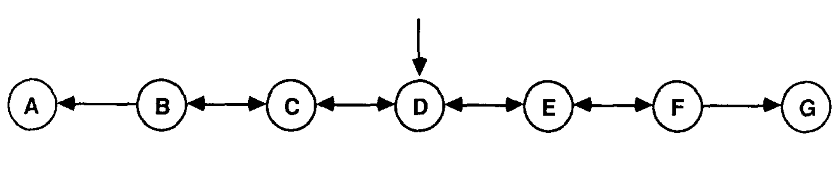Figure 1: Original depiction of the markov process as designed by Sutton from his paper "Learning to Predict by the Methods of Temporal Differences"
Given the basis of this random walk experiment, we seek to find the value of each state. Value as used here, is a relative term with respect to the two aforementioned prediction algorithms. Although, ultimately, both allude to the same thing, the context in which it is used differs. In supervised learning, the value of state is simply the probability of ending up in state G for any given state. In this conventional realm, an input state X_{B}, X_{C}, X_{D}, X_{E}, X_{F} is mapped directly to a prediction P_{t}. This prediction is the measure of “value”. Meanwhile, TD methods correlate value with “how good is it to be in a particular state”. It is an estimate of expected future reward given current state.
From this scenario, two experiments were conducted. The first experiment centering around the proof of TD methods performing better than supervised learning when optimal hyperparameters are used. The second experiment seeks to highlight the underperformance of supervised learning over several permutations of learning rate and prediction methods. In either case, data ingestion during training remained the same.
Data is randomly generated in the form of 100 training sets. Each set contains 10 sequences of walks. There were no restrictions in place dictating how long a walk could be. Therefore, each training set contained walks of random variable length. For both experiments, all 1000 sets were used during training. The difference in implementation between the experiments came with respect to weight updates and convergence objectives. Experiment one seeks full convergence while weight vectors are updated only after seeing all training data. Experiment two presents all data only once while updating weight vectors after seeing one complete sequence. Each experiment will be outlined with greater detail in subsequent sections
Identify applicable funding agency here. If none, delete this text box.

Experiment setup and implementation
The environment utilized for the experiments was Python version 3.7.5 running on Linux Ubuntu 18.04 LTS kernel. The first initiative was the implementation of a Random Walk Data Generator. Using the numpy library version 1.17.2, a class was built that would generate data sets at a user defined amount. Each dataset would contain variable number of sequences, again as defined by a user. Given that Sutton specifically outlined using 100 training sets containing 10 sequences, this ultimately was used. The structure of a single training set is as follows. An entire sequence of a random walk is contained in a Python namedtuple “Walk” which contains two named attributes; Route and Reward.
Route, is the randomly generated walk, vectorized as a M x 7 numpy array. M being the number of transitions taken during the walk. Each row is a unit vector of 6 zeros and a single 1, representative of the current state. Starting from state D, a number is randomly sampled from a uniform distribution between zero and one [0,1] using numpy. If the number sampled is less than 0.5, the action of a left transition is applied and another unit vector is created representative of state C. The opposite is true for a number randomly drawn greater than or equal to 0.5. A unit vector would be created representing state E. An example walk of X_{D}, X_{C}, X_{D}, X_{E}, X_{F}, X_{G} is illustrated in Figure 1
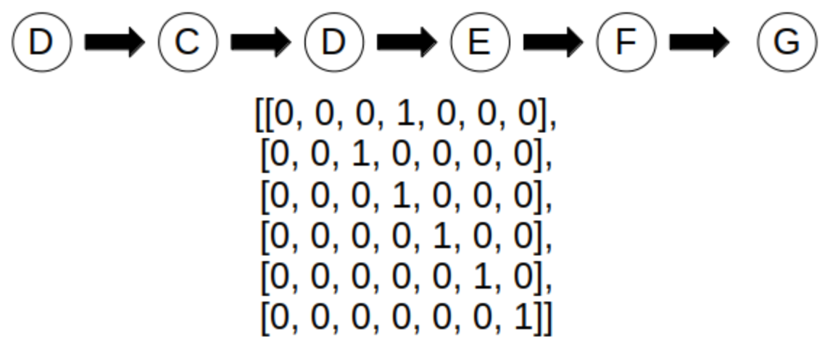Figure 2: Example of random walk that transitions across multiple states and how it is represented in vector format. Index for each row in the array is noted as states A, B, C, D, E, F, G
The Reward attribute of the namedtuple is a single vector of length M – 1. It maintains the rewards received for each transition as randomly generated. This, trivially, is a vector of all zeros except in the instance of a walk ending in state G. The subsequent vector for the walk in Figure XX would be [0, 0, 0, 0, 1]. This was done for ease of indexing during algorithm implementation. The algorithms themselves were reproduced using Python 3.7.5 and Numpy as well.

Experiment I
The first experiment was centered around performance of TD methods versus supervised learning. Sutton dictated that weights were accumulated until termination of the 10th walk of the set and then updated as given by (4). The sets were repeatedly iterative over until convergence. This simply means that all states were initialized to values of 0. For each sequence, the value updates were stored upon reaching a terminal state. State values in this experiment are synonomous with weights. State values were then reset to 0 for the next sequence and the process repeated. After the 10th sequnce, the weight updates are performed and the updated values (weights) are the initial starting values for the next loop of the sequences. Upon convergence, the root mean squared error was calculated between the final state values (weights) and the ideal values as specified by sutton [1/6, 1/3, 1/2, 2/3, 5/6]
The aformentioned steps were performed for all 100 training sets so that the result was 100 different root mean squared errors. These RMSEs were then averaged to give the final error. These steps were repeated for varying levels of lambda in accordance with Sutton’s steps. Sutton failed to specificy two key aspects in his implementation. quation (4) is dependent on a specified lambda and learning rate, alpha. Sutton only makes note to a “best alpha” value, but doesn’t specify what it was. Therefore, multiple permutations of lambda and learning rate alpha were utilized, in search of the reproduction of Sutton’s results. The alpha was found to be 0.01. The second ambiguity was Sutton’s convergence criteria. He only states in the implementation that each training set is repeated until convergence, but not clarifies what this was. The method used in our results was to maintain the previous iteration of all 10 sequences’ weight values as a separate variable. After performing the weight update step, the difference between the previosu weights and the new weights was calculated. If this difference was less than or equal to 0.0001, then convergence was declared. The results from this experiment can be seen in Fig 2. The inset graph is the results from Sutton’s original experiment.
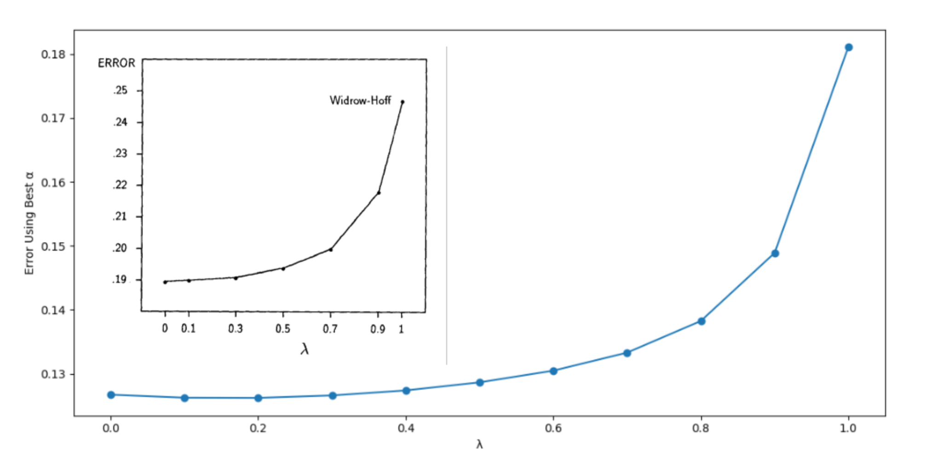Figure 3: Reproduction of Sutton's first experiment. The inset graph is Sutton's original results
It is clear from Figure 2 that TD(1), which is representative of supervised learning, doesn’t perform as well as all other methods of TD(lambda). A way to better think of these results is to consider TD(1) not as supervised learning, but as Monte Carlo updates. When lambda is 1, no n-step averaging is taking place with respect to each update. The full return of all steps is accounted for with respect to the weight update procedure. This is no different than what is done with Monte Carlo methods.
For an episodic task, monte carlo accumulates the entire return value for each episode and then averages the results. One downside to this method is that an entire episode must terminate before anything can be learned, so learning is slower. Another problematic attribute of MC is that it is high variance. That is, it overfits whatever training data is presented to it from a sample, and doesn’t generalize vary well to the entire population that is representative of the environment. If the random generator produces a training set that is very imbalanced to one terminal state over the other, then MC can only learn from what is presented and will tend more to the imbalanced side. It takes in no notion of connectivity or temporal information. TD methods, however, can learn during an episode. It is an averaging of all n-step returns to better represent a Maximum Likelihood estimate.
Note that the overall errors in our reproduction of Experiment 1 are less than those presented by Sutton. There is no “proven” explanation as to the differnece in magnitudes. Multiple training sets were randomly generated in order to find some combination of training sets that would produce such high errrors. We were unable to do so. We can only offer speculation to this, but a potential misinterpreation of the steps to reproduce Sutton’s experiment could have led us to lower errors. The opposite is likely as well, that Sutton performed some computational error during his experiment that went uncaught. The third thought on the matter comes down to the exact training set used. Sutton could have randomly generated a typically unlikely set of sequences that would cause such an increase in error from the norm.

Experiment 2
The next experiment was an exercise in highlighting the shortcomings of supervised learning across a larger space of the hyperparameter alpha. In experiment 1, results were only shown for the best alpha upon convergence for each TD method. Remeber that TD(1) is equivalent to supervised learning. Experiment 2 is an exercise in gridsearch training. This means that multiple lambda values were tested across multiple alpha values. Only this time the values were intialized to 0.5, and each lambda method was not allowed to converge. Instead, each sequence for a given training set was seen only once. During the transitions of a single sequence, the weights were accumulated. Upon reaching a terminal state, the weights were updated with the accumulated weights, and these new weights served as the initial state values for the next sequence in the training set. After all 10 sequences had been seen, the RMSE was calculated using the same ideal values from Experiment 1. Again the end result is 100 RMSE values for the 100 training sets, that were then averaged to give the final error for a given lambda with a specific learning rate alpha. These steps were repeated for multiple values of alpha for each lambda value.
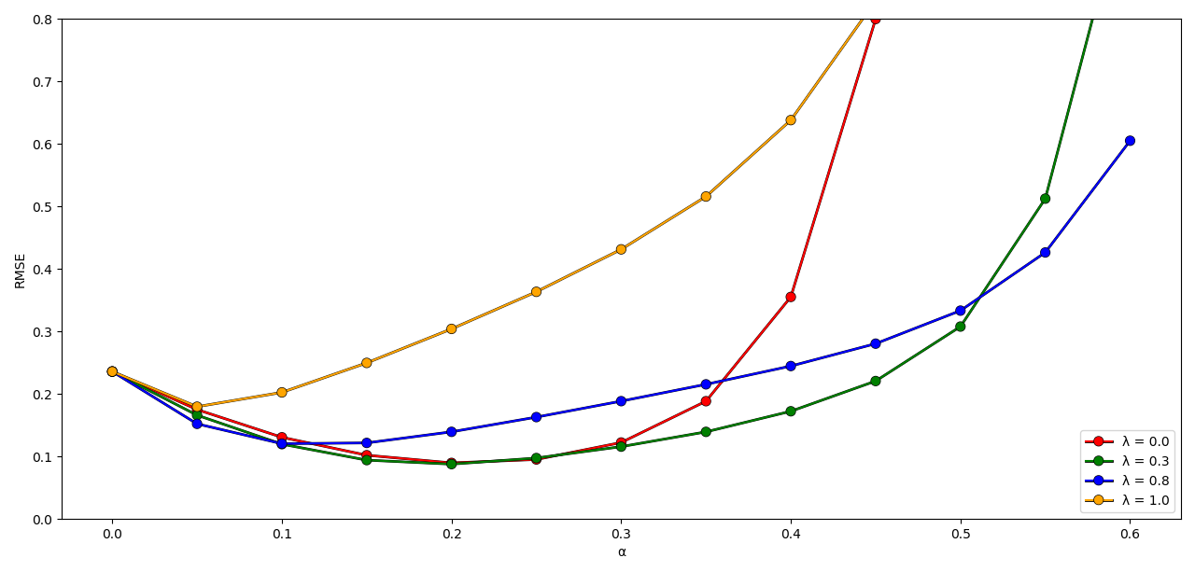Figure 4: Reproduction of Sutton's second experiment.
The results from experiment 2 can be seen in Fig 4. Note that the error for lamda = 0 increases rapidly around alpha = 0.4 and crosses over lambda = 1 for our experiment. This is believed to be due to the length of the training sets generated. Sutton never clarified how long each sequence was in his original training set, nor did he specifiy if there was a maximum length restriction applied. However, when training sets generated by our random generator were limited, we were able to reproduce close to the same results as Sutton. The genereal interpreation of the results is as one would expect in any learning situation. Given some learning rate, there is more or less, a sweet spot in which error is the lowest. As learning rate gets higher, the gradients tend to overshoot either a local or the global optimum and error increases. This is perfectly highlighted in Fig 4. All methods of lambda start to converge until a particular alpha is reached that causes optimization to diverge. In all cases however, each TD method less than 1 performed better than TD(1).
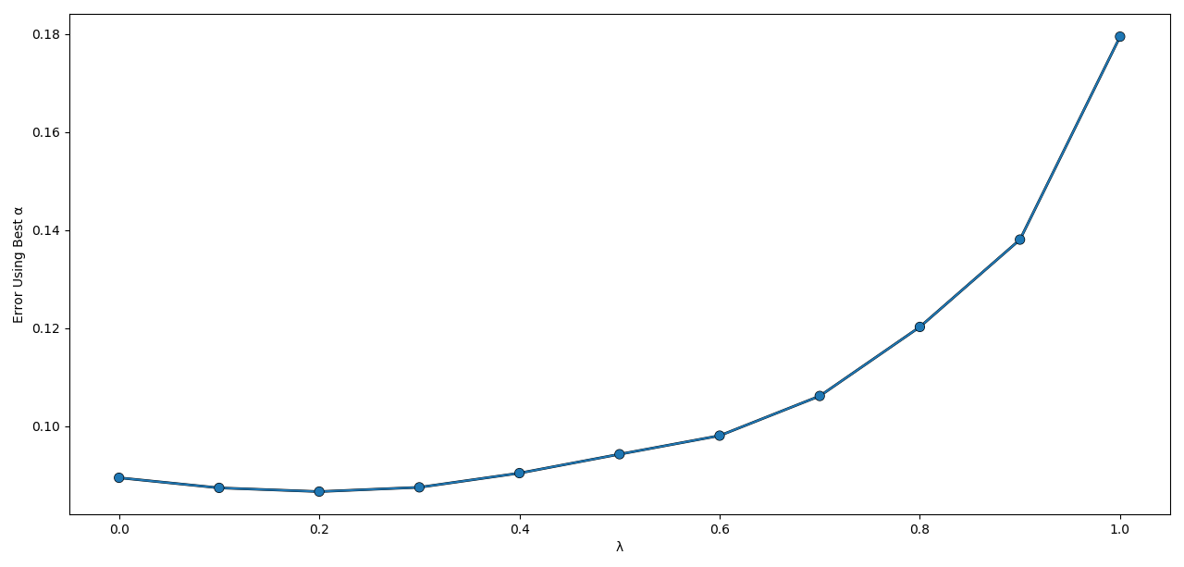Figure 5: Results from Experiment 2 that shows the alpha values for multiple values of lambda that produced the lowest error for that lambda value.
Finally, the best alpha value for several lambda values was extracted from experiment 2 and plotted. The results can be seen in Figure 5. Just as it was seen earlier from experiment 1, supervised learning fails to outperform all lambda values less than 1. The main thing to note here is that lambda of 0 is not the optimal method like it was in Figure 2 from the previous experiment. This is an effect of not allowing convergence of each training set. TD(0) is only a one step look ahead, so it takes multiple updates to the weights before the change at state F, for example, is realized at say, state B. Since each sequence was looped through once, not much information was backpropagated through the states.
One major event of misinterpretation of Sutton’s experiment 2, on our part, had to do with the weight update step. Sutton stated for Experiment 1 that no weights were updated until all 10 sequnences had been seen. With experiment 2, the weights were updated between sequences. Although the wording was clear that it was a backward view¹ implementation, we initially performed an exact online implementation. We were updating the weights inplace between individual transitions in a sequence, not between the sequences themselves. It was only after conferring with fellow students on the appropriate experimental steps that the error was discovered. Upon correcting the updating step, we were able to produce the same general results as Sutton. Surprisingly enough, this one change in placement of the updates greatly changed the results of the experiment. The overall proof these experiments were trying to convey still held true however, that supervised learning methods still are inferior in multi-step programs.
, seen in

Figure Labels: Use 8 point Times New Roman for Figure labels. Use words rather than symbols or abbreviations when writing Figure axis labels to avoid confusing the reader. As an example, write the quantity “Magnetization”, or “Magnetization, M”, not just “M”. If including units in the label, present them within parentheses. Do not label axes only with units. In the example, write “Magnetization (A/m)” or “Magnetization {A[m(1)]}”, not just “A/m”. Do not label axes with a ratio of quantities and units. For example, write “Temperature (K)”, not “Temperature/K”.

Acknowledgment (Heading 5)
The preferred spelling of the word “acknowledgment” in America is without an “e” after the “g”. Avoid the stilted expression “one of us (R. B. G.) thanks ...”. Instead, try “R. B. G. thanks...”. Put sponsor acknowledgments in the unnumbered footnote on the first page.

References
The template will number citations consecutively within brackets [1]. The sentence punctuation follows the bracket [2]. Refer simply to the reference number, as in [3]—do not use “Ref. [3]” or “reference [3]” except at the beginning of a sentence: “Reference [3] was the first ...”
Number footnotes separately in superscripts. Place the actual footnote at the bottom of the column in which it was cited. Do not put footnotes in the abstract or reference list. Use letters for table footnotes.
Unless there are six authors or more give all authors’ names; do not use “et al.”. Papers that have not been published, even if they have been submitted for publication, should be cited as “unpublished” [4]. Papers that have been accepted for publication should be cited as “in press” [5]. Capitalize only the first word in a paper title, except for proper nouns and element symbols.
For papers published in translation journals, please give the English citation first, followed by the original foreign-language citation [6].

- G. Eason, B. Noble, and I. N. Sneddon, “On certain integrals of Lipschitz-Hankel type involving products of Bessel functions,” Phil. Trans. Roy. Soc. London, vol. A247, pp. 529–551, April 1955. (references)
- J. Clerk Maxwell, A Treatise on Electricity and Magnetism, 3rd ed., vol. 2. Oxford: Clarendon, 1892, pp.68–73.
- I. S. Jacobs and C. P. Bean, “Fine particles, thin films and exchange anisotropy,” in Magnetism, vol. III, G. T. Rado and H. Suhl, Eds. New York: Academic, 1963, pp. 271–350.
- K. Elissa, “Title of paper if known,” unpublished.
- R. Nicole, “Title of paper with only first word capitalized,” J. Name Stand. Abbrev., in press.
- Y. Yorozu, M. Hirano, K. Oka, and Y. Tagawa, “Electron spectroscopy studies on magneto-optical media and plastic substrate interface,” IEEE Transl. J. Magn. Japan, vol. 2, pp. 740–741, August 1987 [Digests 9th Annual Conf. Magnetics Japan, p. 301, 1982].
- M. Young, The Technical Writer’s Handbook. Mill Valley, CA: University Science, 1989.
IEEE conference templates contain guidance text for composing and formatting conference papers. Please ensure that all template text is removed from your conference paper prior to submission to the conference. Failure to remove template text from your paper may result in your paper not being published.

